

**Functional Requirements Document**

**ITSR 893988 Customer Experience bot**

**BPA**

**06/30/2020**

**Revision History**

| **Version** | **Date** | **Author** | **Description** |
| --- | --- | --- | --- |
| 1.0 | 6/30/2020 | Kruti Patel | Initial Draft |
| 1.1 | 7/14/2020 | Kruti Patel | Added Section 5.6 (NG/GW add Notes) |
| 1.2 | 8/24/2020 | Kruti Patel | Updated 5.4.2 - Added additional Status for NG EFT/RCP considerations – (Change is tracked under Defect ID: 87158) |
| 1.3 | 04/17/2021 | Teja Ellendula | ITSR 898433 – Identify agency email in the cancellation request and email the agent informing of request to cancel. |

**Approvers and Reviewers**

The following individuals have been identified as the reviewers/approvers for this document. Unless otherwise stated, approvals will be stored in the project folder.

|  |  |  |  |
| --- | --- | --- | --- |
| **Name** | **Title** | **Approve** | **Review** |
| Hector Martinez | Mgr. Cust Relations Admin | X |  |
| Tina Strom | Spvsr. Customer Relations |  | X |
| Lawrence Valderama | Support Specialist Sr. |  | X |
| Nicole Vilchis | R&I Analyst |  | X |
| Kevin Bailey | Dir, UW R & I |  | X |
| Shaguna Virmani | Mgr., Applications Dev |  | X |
| Mon-Loe Lee | SW Dev Analyst Principal |  | X |
| Susy Ongko | Project Manager II |  | X |
| Kruti Patel | SW Dev Analyst Associate |  | X |
| Eva Alvarado | BSA Principal |  | X |
| Annie To | BSA I |  | X |
| Ushabharathi Chittoor | QA |  | X |

Table of Contents

1 Overview 3

2 Scope 3

3 UAT 3

4 Assumptions and Constraints 4

5 Functional Requirements – Processing Customer Experience Bot 4

6 Security Considerations 10

7 Application Controls 10

# 

# Overview

This document describes the Robotic Process Automation (RPA) for the Customer Experience bot that will read the emails in the Customer Experience Mailbox and forward the policy cancellation emails to [UWDistributionServices@mercuryinsurance.com](mailto:UWDistributionServices@mercuryinsurance.com) and Autopay - [Autopay@mercuryinsurance.com](mailto:Autopay@mercuryinsurance.com) for the applicable Auto-Pay policy.

# Scope

* The following are the Customer Experience Bot scope:
  + BOT to check unread emails from Customer Experience Inbox on a daily basis (twice a day).
  + BOT will verify if the keywords are present in the Email Subject and Body.
  + BOT will verify that the policy number and driver names match between GW & NG system; if they do not match, BOT will move the email to BOT Not Completed folder.
  + BOT will check whether or not the policy is an Auto Pay policy and forward the email accordingly to the appropriate group and move the email from Inbox to BOT Completed folder.
* Systems: Outlook/GW/NG
* States:
  + All Applicable States
* Line of Business:
  + All (HO, BA, PPA, LL, CMP, EQ)

# UAT

## UAT Testers

|  |  |
| --- | --- |
| **Name** | **Title** |
| Lawrence Valderama | Support Specialist Sr. |
| Hector Martinez | Mgr. Cust Relations Admin |
| Tina Strom | Spvsr. Customer Relations |

## UAT Success Criteria

## If policy is an Auto Pay policy, then BOT should forward Email to [UWDistributionservices@mercuryinsurance.com](mailto:UWDistributionservices@mercuryinsurance.com) and [Autopay@mercuryinsurance.com](mailto:Autopay@mercuryinsurance.com)

## If policy is not an Auto Pay policy, then BOT should forward Email to [UWDistributionservices@mercuryinsurance.com](mailto:UWDistributionservices@mercuryinsurance.com) only

## BOT will move the email from Inbox to BOT Completed folder once the email forwarding is done.

## If Policy Number and Driver names (PNI/Spouse) do no match, BOT should move the email to BOT Not Completed Folder.

## For keywords not found in Email Subject/Body, BOT should move the email to BOT Not Completed Folder.

### Bot will forward the emails to agency emails to appropriate agency based on the full agency code.

# Assumptions and Constraints

* The Customer Experience BOT process will be processed by an unattended bot.
* The process will not impact the actual application (NG and Guidewire); the bot is a software that is installed in VDI (virtual machine) and runs scripts to open applications and execute steps as defined in the FRD.
* Robotic processing is not intended to replace application programming.
* Robotic processing is not intended to address all possible scenarios.
* For any exception occurrence, BOT should move the email to BOT Not Completed Folder and business should process the emails manually.
* BOT will only process unread emails on a daily basis.

# Functional Requirements – Processing Customer Experience Bot

## Step 1: Check Incoming and Unread Emails from Customer Experience Inbox.

## BOT should have access to Customer Experience Mailbox and BOT will check incoming emails that are unread on a daily basis.

## BOT will read unread emails’ Subject & Body and verify if any of the following keywords are present in the email:

* Cancel
* Terminate
* Switch
* No longer need
* Requesting termination
* Found other insurance
* Refund

### If email body contains “AUTOMATED FORWARD TO AGENCY”, bot will move to step (5.7).

## If any of the Keywords is Present, BOT will check if Policy Number is Present in the Email Subject or Email Body. If it’s Present then move to Step 2 (5.2).

## If a Keyword is not Present AND Policy Number is not present in the Email Subject or Email Body, then

* BOT will skip Processing Email and move the Email to BOT Not Completed Folder.

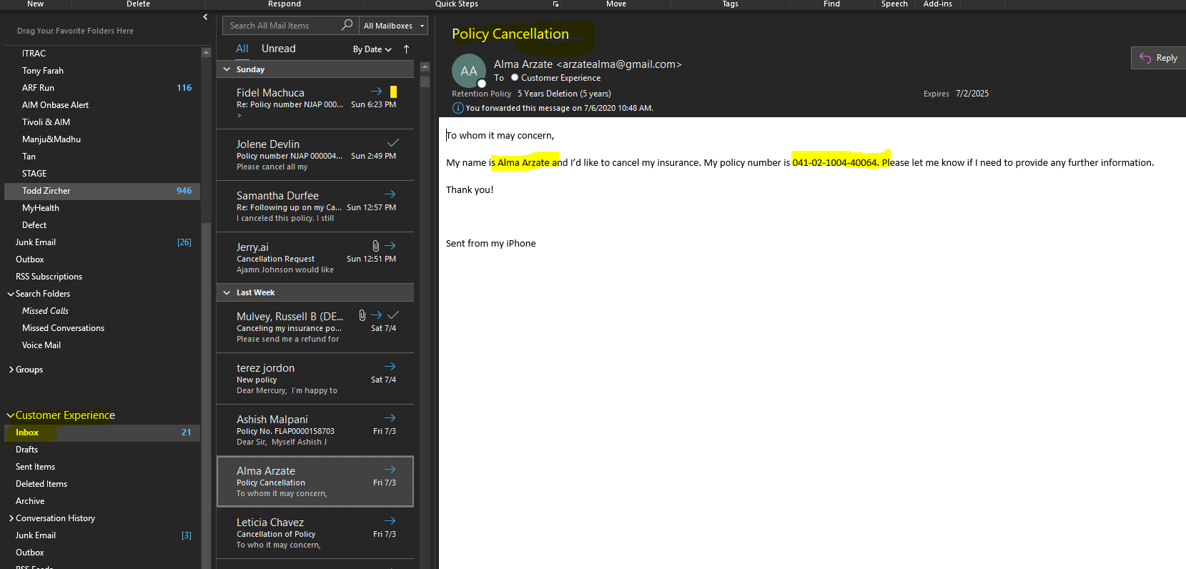

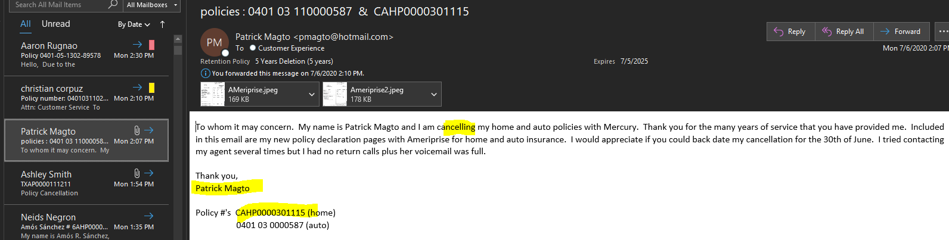

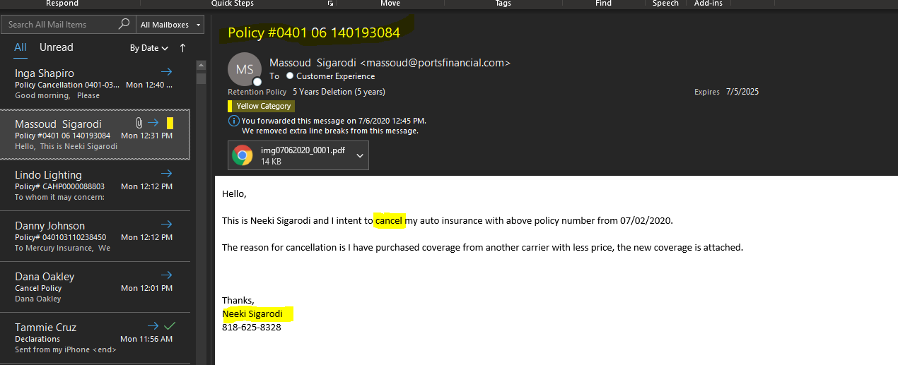

## Step 2: Verify If PolicyNumber is Valid

## Bot will verify if Policy Number is valid and present in NG and GW systems by making an EIS Policy Retrieve webservice call.

## If Policy # is a valid number, then BOT will move to Step 3 (5.3)

## If Policy # is not valid and not present in GW and NG systems, then

* BOT will skip Processing Email and move the Email to BOT Not Completed Folder.

## Step 3: Compare Driver PNI/Spouse name is present in Email Body/Subject

## BOT compares the Driver names (PNI/Spouse) from GW and NG systems to the Email Body/Subject.

## BOT will use FirstName & LastName from the PNI/Spouse in the policy and see if either FirstName or LastName exists in the Email Body/Subject.

1. If FirstName or LastName Present, then BOT will move to Step 4 (5.4)
2. If FirstName or LastName not Present, BOT will skip Processing Email and move the Email to BOT Not Completed Folder.

## Step 4: Check if Policy is Auto Pay in GW & NG

## GW Policy

1. BOT will login to GW 🡪 Search Policy 🡪 Navigate to Billing/Payment
   1. If Automatic Payments has masked Bank Account or Credit/Debit Card Number, then BOT should consider policy as Auto-Pay policy. Move to Step 5 (5.5)
   2. If Automatic Payments has a value as “No”, then BOT should consider policy as Non-Auto-Pay policy. Move to Step 5 (5.5)

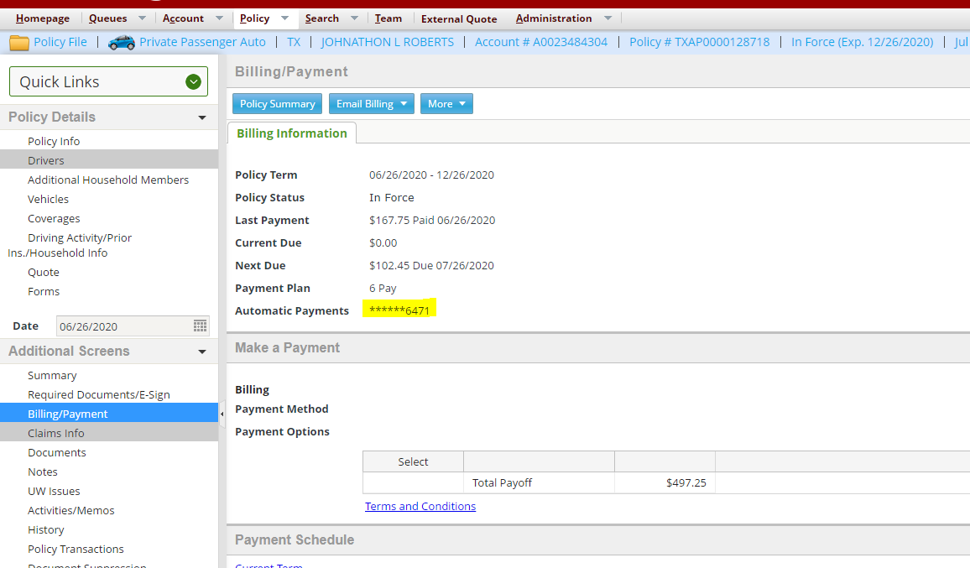

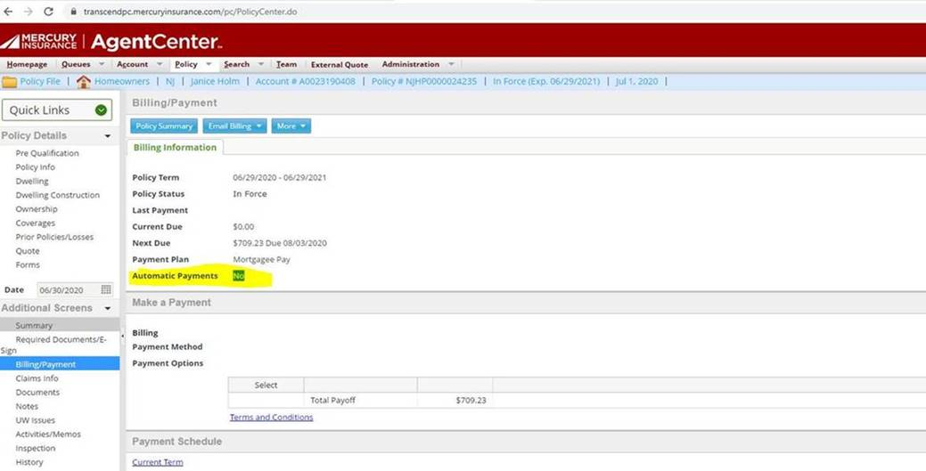

## NG Policy

1. BOT will login to NG and navigate to Inquiry 🡪 Billing 🡪 Find Policy
2. If EFT/RCP Status equals to (“Active”) OR ("Pre-Note") OR ("Approved") OR ("Entry Made"), then BOT will consider the policy as an Auto Pay policy. Move to Step 5 (5.5)
3. If EFT/RCP Status does not equal to Active or it’s blank, then BOT will consider the policy as a non-Auto Pay policy. Move to Step 5 (5.5)

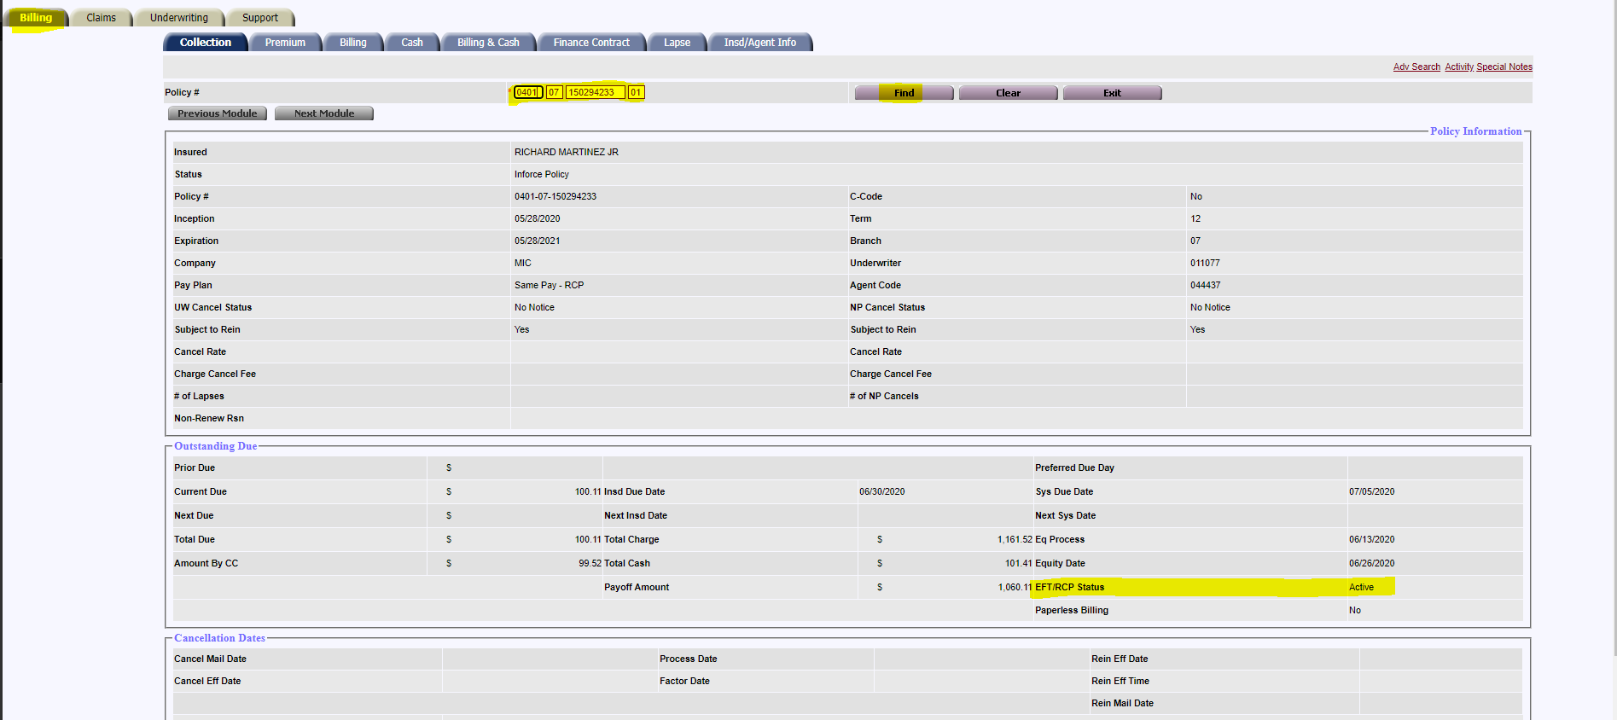

## Step 5: Forward Email and Move Email to BOT Completed folder

## If policy is an Auto Pay policy, then BOT will forward Email to [UWDistributionservices@mercuryinsurance.com](mailto:UWDistributionservices@mercuryinsurance.com) and [Autopay@mercuryinsurance.com](mailto:Autopay@mercuryinsurance.com). and Also, bot will forward the original email to the agency email as below:

## If policy is not an Auto Pay policy, then BOT will forward Email to [UWDistributionservices@mercuryinsurance.com](mailto:UWDistributionservices@mercuryinsurance.com) and Also, bot will forward the original email to the agency email as below :-

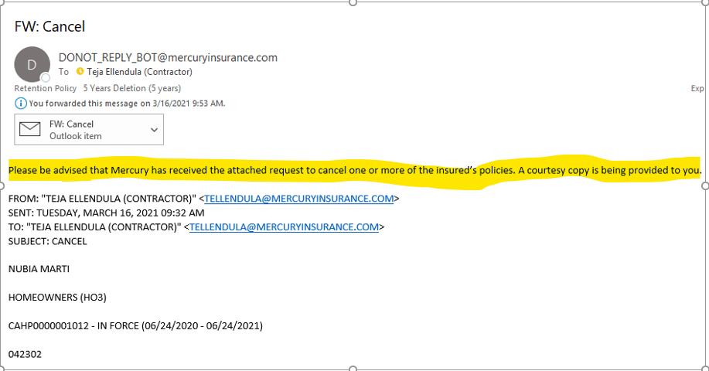

## BOT will move the email from Inbox to BOT Completed Folder once the email forwarding is done. Move to Step 6 (5.6)

## Step 6: Add Notes

## BOT should add Notes in GW or NG system once the email has been forwarded and moved to BOT Completed Folder.

**GW Notes:**

* **Subject**: Cancellation Request Received and Forwarded
* **Note**: Emailed Cancel Request received and Forwarded to <one or both applicable email addresses here> by bot.

**NG Special Note:**

* **Subject**: Cancellation Request Received and Forwarded
* **Note**: Emailed Cancel Request received and Forwarded to <one or both applicable email addresses here> by bot.

## Agency Emails

### Bot will read emails and verifies if the email body contains “AUTOMATED TO FORWARD AGENCY” as below:

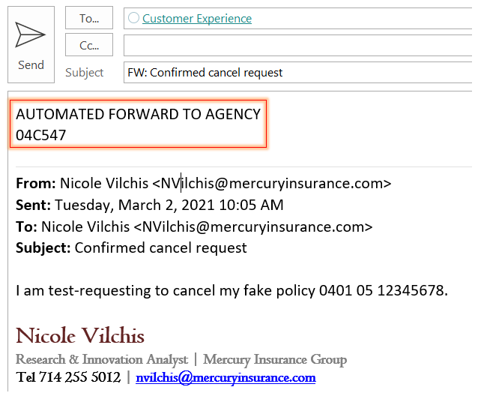

### If the email body contains above wording, bot will extract agency code from the body.

Bot will use above agency code to retrieve agency email and forward the original email as below: 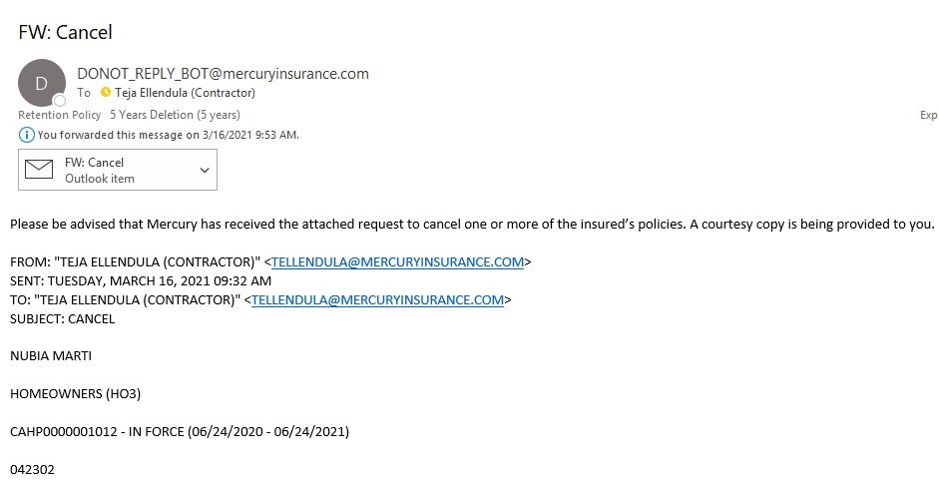

### If bot unable to find the agency email from the list, bot will forward the email to [jcisneros@mercuryinsurance.com](mailto:jcisneros@mercuryinsurance.com); LValderama@mercuryinsurance.com.

## BOT will move the email from Inbox to BOT Completed folder once the email forwarding is done.

### If agency emails are associated with mercury insurance, bot will skip forwarding process.

## Error Handling

### The Process is triggered, and a failure occurs in the middle of a process

#### Email is sent to the bot team with a screen shot of the error; the email content will include the step where the failure occurred.

# Security Considerations

Security is not changing as part of this implementation.

# Application Controls

To ensure that all appropriate application controls are included in the Functional Requirements Document, the Business Analyst must complete the Application Controls Table.

**Application Controls Table**

| **ACO #** | **Application Control Objective (ACO)** | **Financial Statement Assertion** | **Applicability Explanation**  **(Yes or No and why)** |
| --- | --- | --- | --- |
| ACO-01 | Ensure **adherence to defined business rules** in the flow and accuracy of processing | Accuracy, Completeness, Validity | Yes, section 5 |
| ACO-02 | Ensure that **only authorized transactions** are input and accepted by the application | Validity | Yes, section 5 |
| ACO-03 | Ensure that **only accurate data** are input and accepted by the application | Accuracy | Yes, section 5 |
| ACO-04 | Ensure that transactions are **processed completely** (no more, no less) **within an application** | Completeness | Yes, section 5 |
| ACO-05 | Ensure that transactions are **processed completely** (no more, no less) **between an application and its internal and external interfaces** (both inbound and outbound) | Completeness | Yes, section 5 |
| ACO-06 | Ensure that **system generated transactions** and **values** are **accurate and reliable** | Accuracy | No, system doesn’t generate any transaction |
| ACO-07 | Ensure that **system calculations** are **accurate** | Accuracy | No, there’s no system calculations |
| ACO-08 | Ensure that **errors and exceptions** (e.g., transaction reversals, overrides, error corrections) **are handled properly**, with the appropriate level of authority and audit trail | Validity, Completeness | Yes, section 5 |